**Awards Received:**

* **LEED Gold**
* **DBIA Western Region**

Nominated for:

* Lab of the Year
* DBIA National
* Building Design & Construction
* IIDA Calibre
* LA Business Journal / CRE
* LA Business Council
* Engineering News-Record Regional
* ENR Year in Construction

TIANQIAO & CHRISSY CHEN NEUROSCIENCE RESEARCH BUILDING

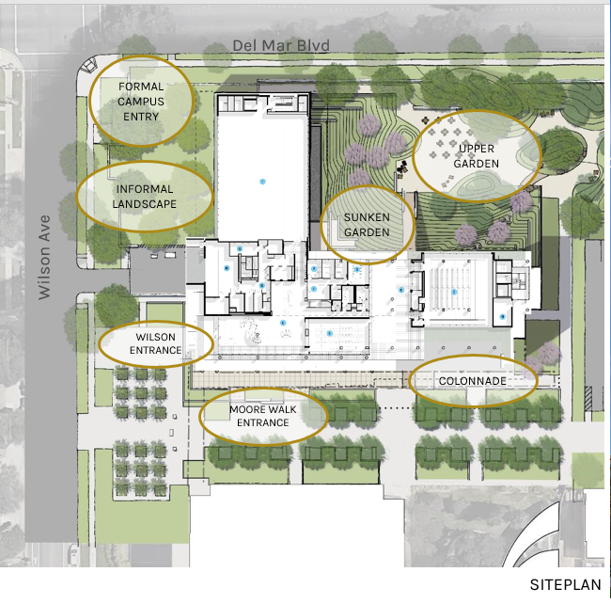

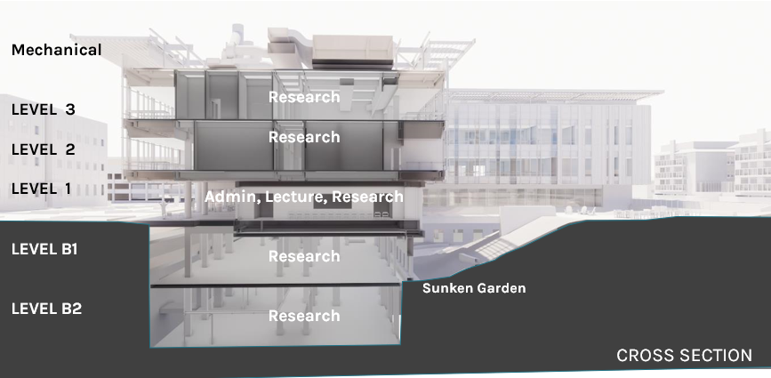

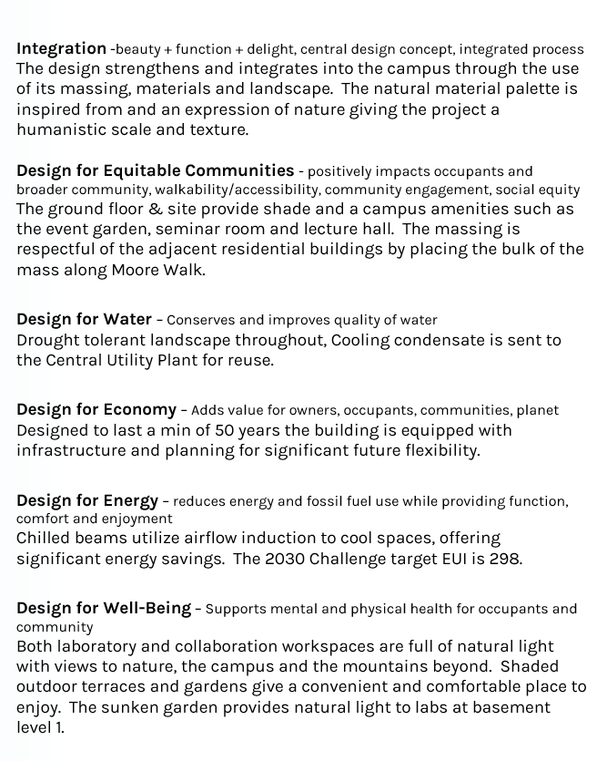

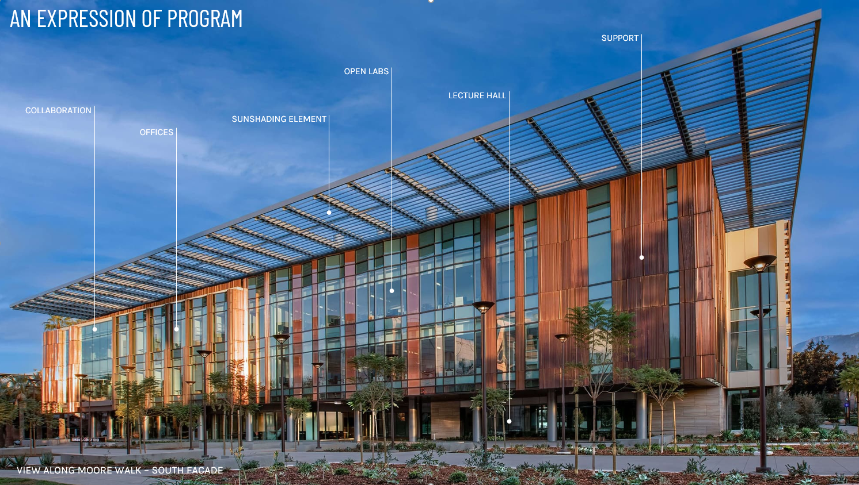



**Tianqiao & Chrissy Chen**

**Neuroscience Research Building**

**Fact Sheet & Occupation Information**

**Avoiding Disruptions**

**Powered by Fuel Cells**

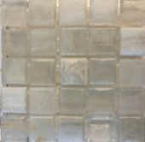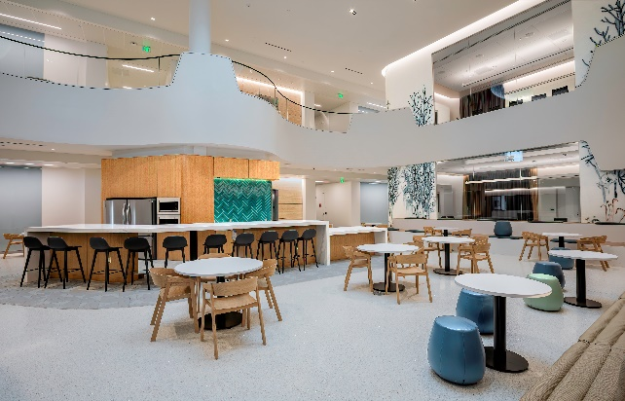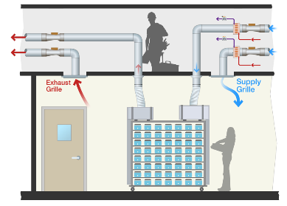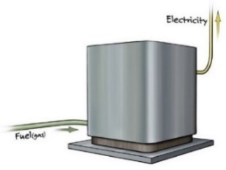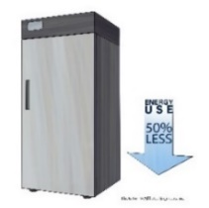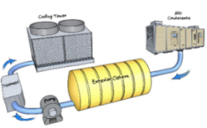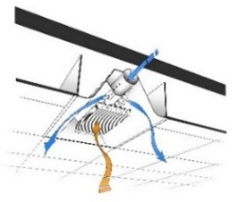Cable coil icon. Simple illustration ... | Stock vector | Colourbox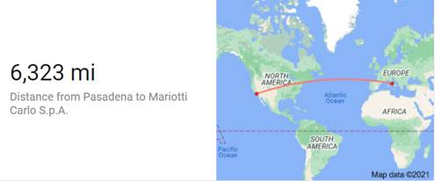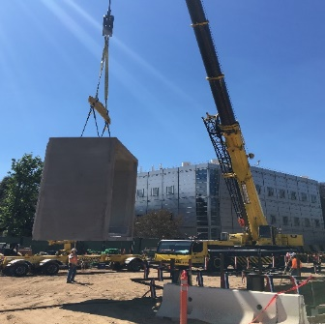

**Finishes/Furniture:** The finishes selected were durable, bleach cleanable, and meets stringent chemical emission limits for various VOCs.

**Art Installation:** Artwork depicting the human brain is located in the lobby. This artwork was gifted from Tianqiao Chen and Chrissy Luo and is the work of Greg Dunn.

**Innovative Lab Design:** To meet the unknown research needs of tomorrow, the piped utilities/gasses in labs are set up in a flexible manner to allow for multiple configurations via mobile base cabinets, adjustable tables and ceiling service panels.

**> Pounds of Sheet**

**Metal in Ductwork**

150,000+ sf

1,230 tons

**> Tons of**

**Steel**

**> Size of**

**Facility**

**Building Construction & Occupancy**

10,500 cubic yards

**> Concrete**

**> Dirt**

**> Copper Exterior**

**> Skylight**

**> Chilled Beams**

**> High Efficiency Freezer**

Utilize airflow induction and chilled water to cool spaces, offering significant energy savings.

**> Water Reuse**

**Sustainability**

Features 545,326 mosaic tiles designed to bring natural light into the nucleus of the building.

Greater overhead clearance and overhead catwalks were installed over the B2 Level. This was done to allow necessary maintenance activities to occur overhead while avoiding the unacceptable disruption of research occurring in spaces below.

**> Connected by a Tunnel**

**> Travertine Stone**

Lower levels of the building are clad with 22,700 square feet of travertine stone. This featured stone can be found at elevator fronts, the lobby, bridge, breezeway, and sunken garden.

The featured stone was fabricated in Italy at the Marrioti family travertine quarry which has been in operation for over 800 years and is now operated by the fourth generation of family ownership. Each piece of stone weighs 250 lbs. The stone traveled 6,323 miles from Italy to its new home in the Chen Building.

The artwork in the photo was inspired by Santiago Ramon Y Cajal (1852-1934), a Spanish neuroscientist and pathologist, specializing in the neuroanatomy, particularly of the histology of the central nervous system. His original investigations of the microscopic structure of the brain made him a pioneer of modern neuroscience. Hundreds of his drawings illustrating the delicate arborizations ("tree growing") of brain cells are still in use for educational and training purposes. The artwork is a multi-story piece that spans the first, second and third levels of the lobby.

**> Lobby Artwork**

**Quick Facts**

Approximately 2,700

500, including 100 visitors

3.5 years

Sit-stand desks are provided at write up stations and in offices, allowing researchers the flexibility to sit, stand, and move to help maintain better focus over long hours examining research data. Ergonomic seating can also help minimize injuries.

244,000+ lbs

205 miles

**Energy Efficiency**

Enhanced operational design reduces energy consumed and heat rejected.

Cooling Coil Condensate is sent to the Central Utility Plant for reuse.

Chen’s primary source of power is a 1MW natural gas fuel cell, sized to meet all of the buildings electrical demand. In case of disasters, the local utility (PWP) and onsite emergency generators provide two alternate power sources.

**> Duration of Design & Construction**

**> Number of Individuals Involved in**

**Design & Construction**

**> Ergonomics**

**> Number of Planned Occupants**

**Chen**

**Research Building**

**Average**

**Caltech Research Building**

Chen as a research and energy intensive building will consume approximately 295 kBtu/sf/year. This compares favorably to the Caltech average for research buildings of 411 kBtu/sf/year.

* **Caltech is highly committed to sustainability. The following reflect that commitment:**

**> Miles of**

**Wire**

Fabricated in Rome, NY from a mixture of recycled and raw copper.

B2 Level of the building is connected to the Broad Building via a pedestrian tunnel. To minimize the duration and associated disruption the tunnel was constructed with 10 pre-cast tunnel sections. Each precast section was 12’x12’x10’ long and weighed approximately 40 tons.

**6,323 mi**

Distance from Pasadena to Mariotti Carlo S.p.A

63,000 cubic yards of soil evacuated